1. Exercise 1: Basic HTML5 Structure Objective: Understand the basic structure of an HTML5 document.

<!DOCTYPE html>

<html>

<head>

<title>MY FIRST HTML PAGE!</title>

</head>

<body>

<h1> Jai vishal R </h1>

<hr>

<p >hobbies:<br> love listening to music, rap , sketching and travelling</p>

</body>

</html>

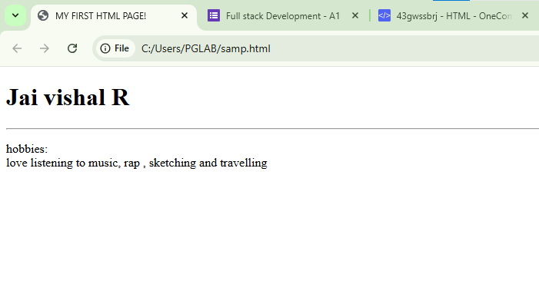

2.Exercise 2: Use of Lists and Links Objective: Practice using different list types and hyperlinks.

<!DOCTYPE html>

<html>

<head>

<title>exercise 2</title>

</head>

<body>

<h1>favorite fruits</h1>

<hr>

<ul>

<li> grapes </li>

<li> apple</li>

<li> banana</li>

</ul>

<h1>favorite movies</h1>

<hr>

<ol>

<li> conjuring</li>

<li> nun </li>

<li> anabelle </li>

</ol>

<a href="https://www.youtube.com/" target="_blank"> fav website : youtube </a>

</body>

</html>

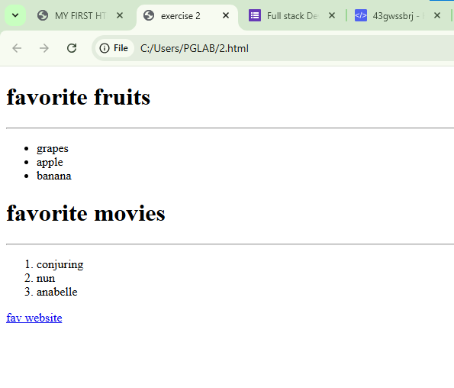

3. Exercise 3: Adding Images and Tables Objective: Insert images and create tables using HTML.

<!DOCTYPE html>

<html>

<head>

<title>Exercise 3 Images and Tables</title>

</head>

<body>

<h1>Image Example</h1>

<img src=""vk.jpg"" alt="Placeholder Image">

<h1>Student Information Table</h1>

<table border="1">

<tr>

<th>Name</th>

<th>Age</th>

<th>FavoriteSubject</th>

</tr>

<tr>

<td>jai</td>

<td>22</td>

<td>fsd</td>

</tr>

<tr>

<td>vishal</td>

<td>22</td>

<td>aos</td>

</tr>

<tr>

<td>jaivishal</td>

<td>22</td>

<td>English</td>

</tr>

</table>

</body>

</html>

. 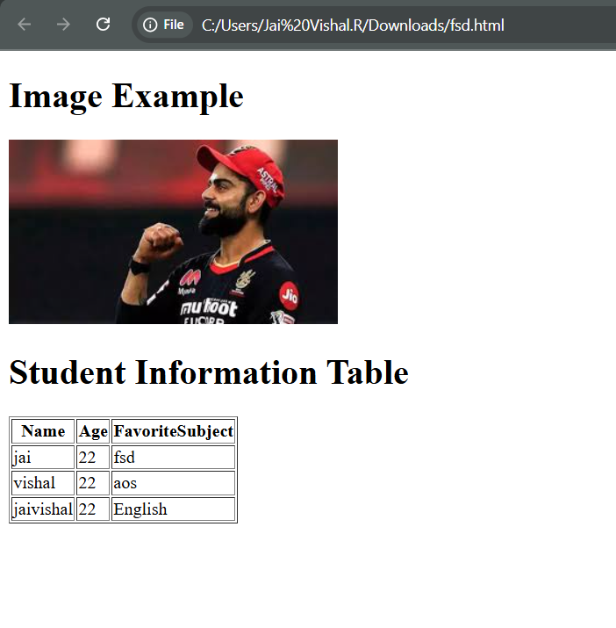

4. Exercise 4: Introduction to CSS (Internal CSS) Objective: Apply basic styles to HTML using

<!DOCTYPE html>

<head>

<title>Exercise 4: Internal CSS</title>

<style>

h1 {

background-color: lightblue;

color: darkblue;

font-size: 30px;

}

p {

font-family: Arial, sans-serif;

text-align: justify;

}

</style>

</head>

<body>

<h1>VIRAT KOHLI</h1>

<hr>

<p>

This is a paragraph about virat kohli styled using internal CSS.<br> The text is justified and uses the Arial font family to demonstrate how internal CSS can be applied directly within the HTML document using the style tag.<br>Virat Kohli (born 5 November 1988)[b] is an Indian international cricketer who plays Test and ODI cricket for the national team and is a former captain in all formats.[5] He is a right-handed batsman and an occasional right arm medium pace bowler. He is called the king, the chase master and the run machine for his playing style, records and ability to lead the team to victory.[6] Kohli is the highest run-scorer in the Indian Premier League, third in T20I, third in ODI, and third in international cricket.[7] Regarded as one of the greatest batsmen of all time, he holds the record for the most ODI centuries and has the second most centuries in international cricket.[8] Kohli is also the only captain to lead India to three consecutive Test mace wins during 2017, 2018, and 2019.[9]He is the only batsman to achieve 900 rating points in all 3 formats.[1]

Kohli led the Indian team to victory at the 2008 U19 World Cup and was a key member of the teams that won the 2011 ODI World Cup, 2013 Champions Trophy, 2024 T20 World Cup and 2025 Champions Trophy. He represents Royal Challengers Bengaluru in the Indian Premier League and Delhi in domestic cricket. In 2013, Kohli was ranked number one in the ODI batting rankings. In 2015, he achieved the same in T20I.[10] In 2018, he was ranked the number one Test batsman, making him the only Indian to hold the number one spot in all three formats. He is the first player to score 20,000 runs in a decade. ICC named him the male cricketer of the decade for the years 2011 to 2020.

</p>

</body>

</html>

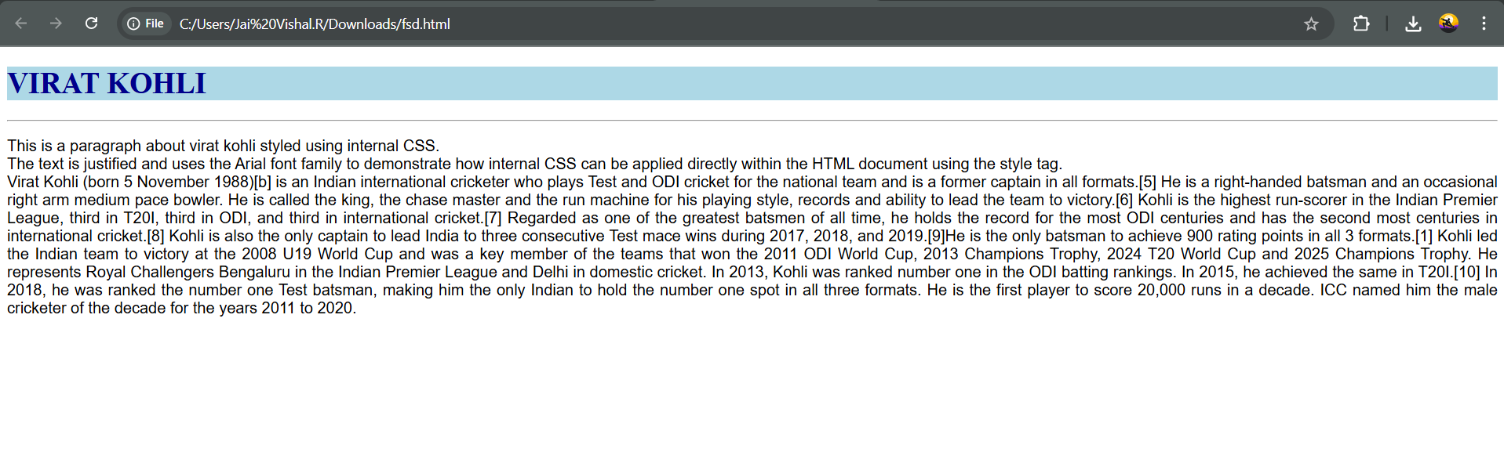

5. Exercise 5: CSS Classes and IDs Objective: Learn to differentiate and apply CSS classes and IDs.

<!DOCTYPE html>

<head>

<title>Exercise 5: CSS Classes and IDs</title>

<style>

#intro {

border: 2px solid black;

padding: 15px;

}

.highlight {

background-color: yellow;

}

</style>

</head>

<body>

<div id="intro">

using border and padding as mentioned in the question for ID

</div>

<br />

<hr>

<div class="highlight">

yellow background division using class

</div>

</body>

</html>

